Software Requirements Specification
Version 4.0
28 October 2026
Setshabelo Admission System
Group 0: Secret Design
Group Members:
Relebohile Thito
Lebohang Molise
Tshepo M Masimong
Lonwabo Sifumba
Andries M Matona
Njabulo R.A Mthethwa

Table of Contents
1. Introduction 6
2. Problem Statement 6
3. Purpose, Aim and Objectives 6
4. Project Scope 6
5. Stakeholders and user groups 7
6. Current process 7
7. Product Perspective - Flutter, ASP.NET and Supabase functions 8
8. Requirements Table 9
UNIT 2 - Feasibility Analysis 11
9. Review of current project 11
10. Technical Feasibility Evaluation 13
11. Operational Feasibility Evaluation 13
12. Economic Feasibility Evaluation 14
13. Schedule Feasibility Evaluation 15
14. Legal Feasibility Evaluation 15
15. Ethical Feasibility Evaluation 16
16. Feasibility Summary 17
17. Risk Register 18
18. Mitigation and Contingency Plans 19
19. SWOT Analysis 21
20.Refined Project Scope 22
21. Updated Requirements 22
22. Evidence Appendix 23
UNIT 3 – System Architecture & Design 27
23. Main System Components 27
24. System User and Roles 27
25. Component Responsibilities 27
26. Main Data Flows 28
27. System Architecture Diagram 29
28. UML & Database Design 30
29. Identifying Use Cases 30
30. Use Case Diagram 31
31. Sequence Diagrams 32
32. Entity Relationship Diagram 34
33. Required Flutter Screens 35
34. Required ASP.NET Screens 35
35. Flutter Mobile Navigation Flow 36
36. ASP.NET Web Navigation Flow 36
37. Mobile & Web Integration 37
38. Stakeholder Feedback 37
39. Updated System Design 37
40. Unit 3 Evidence 38
Unit 4: System Development and Implementation 43
41.Approved Database Design Review 43
42. Backend for both applications 43
43. Approved Mobile Application Requirements 44
44. Mobile Application Flow 44
45. Developed Mobile Screens 45
46. Web Application Requirements 53
47. Web Application Flow 53
48. Developed Web Screens (Admin) 54
49. Approved Integration Design 57
50. Complete Integrated Application 58
51. Unit 4 Evidence 59

1. Introduction
The purpose of this document is to present a detailed description of the Setshabelo Admission System. It will explain the purpose and features of the system, what the system will do, constraints under it will operate. This document is intended for both the stakeholders and the development team.

2. Problem Statement
Setshabelo Primary School currently uses onsite registrations where parents need to come to school to premises at the beginning of the year to apply for their children. This may result in missing information and wrongly filled documents. The problem affects parents because they need to queue on long lines and it also affect the administration staff because they must process a lot of papers at once. The school requires a more streamlined and organised method of receiving applications. The school also uses social media as a form of communication with parents and students which some parents won’t always have access to.

3. Purpose, Aim and Objectives
The purpose of the prototype is to simplify the application process for new learners; the updates sent to parents and learners by the school and publishing school achievements to the general public as a form of advertising and attraction. The Simplification includes digitalizing the process of applying, making sure all the school updates are easily accessible.

4. Project Scope
Scope Element | Group Response
Project title | Setshabelo Admission System
Aim | Develop an integrated prototype for creating and managing learner applications and school updates
Objectives | - Allow parents to create and view applications for their children and have access to any school updates  - Allow school admins to accept and reject applications  - Allow the admins to publish school updates  - Allow users to view school achievements
Deliverable | Integrated Flutter and Asp.net web/mobile application
Acceptance criterion | - Flutter and Asp.net will share the same backend  - Users can use both mobile and web for the same actions
Exclusions | - Built-in uniform shop  - Day-to-day attendance register  - Built-in textbook library  - Bulk SMS
Constraints | - Time – Project must be completed before the end of the semester  - Cost – Attendance scanner is out of defined budget  - Scope: Uniform partnership already exists. E-textbooks distributions violate copyright laws
Assumptions | - Parents have a compatible device to use the application/website (Smartphone or computer)  - Parents and Administrative staff have basic digital skills to navigate a web or mobile application  - A secure authentication system will be implemented to differentiate between users and admin stuff  - The team has necessary technical skills to develop the needed system

5. Stakeholders and user groups
Stakeholder or User | Role in the proposed system
External stakeholder | Define the current process and problems tied to it.
Mobile application user | - User – Create application, view application status, view school updates, view school achievements  - Admin – View and manage applications, publish school updates, publish school achievements
Web application user | - User – Create application, view application status, view school updates, view school achievements  - Admin – View and manage applications, publish school updates, publish school achievements

6. Current process
6.1 Application Period announcement – The school announces the start of the new year application period through social media or verbal announcements.
6.2 Parents travel to school – Parents must take time off work or arrange transport to physically travel to the school during the application window.
6.3 Queuing – Parents join long, physical queues with many other applicants at school, this results in long waiting times.
6.4 Manual form collection – Once they reach the front of the queue, parents receive a physical/paper application form from the admin staff.
6.5 Manual form filling – Parents fill out the papers by hand; this usually leads to wrongfully filled documents.
6.6 Form submission – Parents submit the completed physical forms back to the admin stuff, along with any required documents.
6.7 Submitted forms – Admin stuff collects and piles up all the submitted paper applications from many parents over several days.
6.8 Manual form processing and decision making – Admin staff must process many paper documents at once. They manually review each form to either accept or reject the application.
6.9 Outcome – The school relies on social media to communicate outcomes, school updates and important information back to parents.
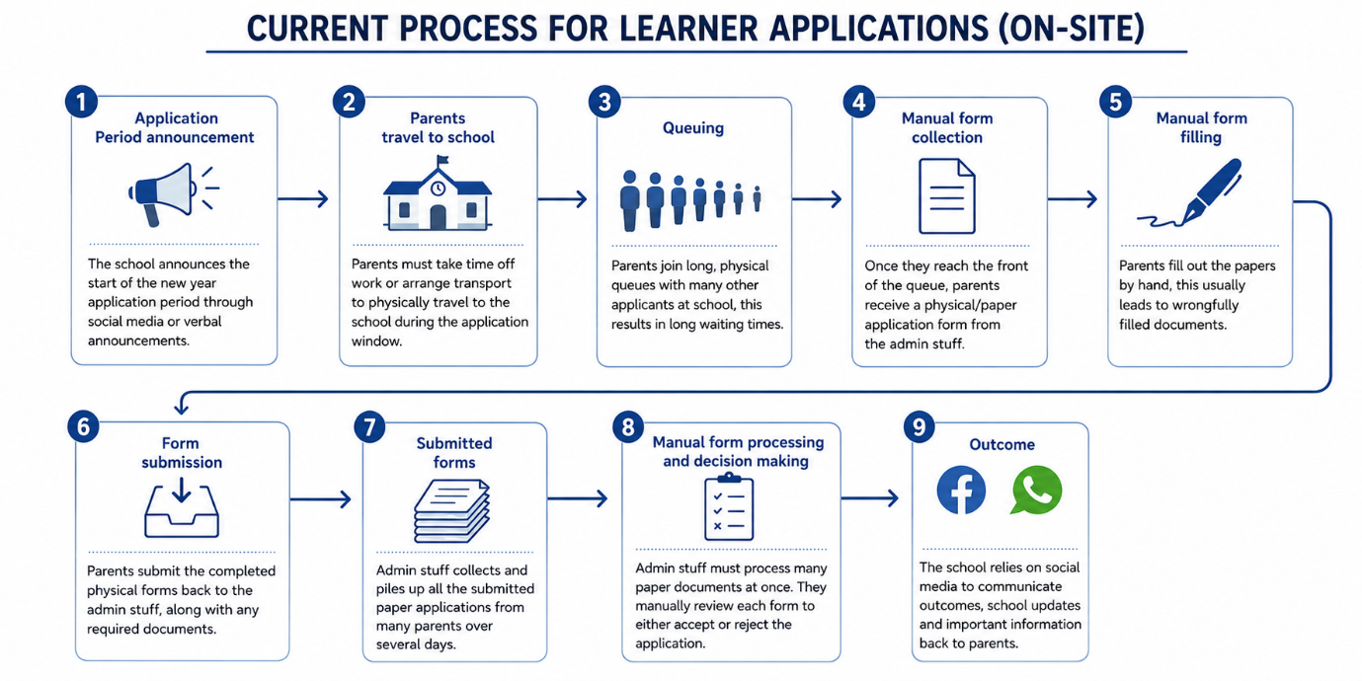

7. Product Perspective - Flutter, ASP.NET and Supabase functions
The prototype will operate as one integrated system. Supabase will be the backend of both ASP.Net and Flutter. ASP.Net and Flutter will be used for the web and mobile development respectively. Supabase will handle all the logic, data storage, accounts storage, and security. Flutter will use MVVC for the development of the mobile version while ASP.Net uses MVC for the development of the web version. A user/parent will create an account on either the mobile application or the web application, their account information will be stored on the Supabase. When completing an application form on the mobile information the same information will be reflected on the web application when they login using the same account they used to apply. Administrators of the application will be able to login on the web application and view submitted applications. Administrators will then accept applications or put them under review and if some information is entered wrong, they will be able to leave a comment that will show on the users’ side of the application.

8. Requirements Table
ID | Requirement | Type | Priority | Related Stakeholder need
FR1 | Parents must be able to create accounts | Functional | Must Have | Parents need a way to register themselves digitally to access the application system.
FR2 | Parents must be able to create applications for their children | Functional | Must Have | Parents need a convenient way to apply from home without traveling to the school or filling out paper forms.
FR3 | Parents can view the application status | Functional | Must Have | Parents need clarity on whether their child has been accepted without waiting for social media posts or phone calls.
FR4 | Only Admin Stuff can accept and reject applications | Functional | Must Have | Admin Stuff need a streamlined way to process decisions quickly
FR5 | Parents can view school updates | Functional | Must Have | Parents need a reliable way to receive school communications
FR6 | Parents can view school achievements | Functional | Must Have | School Administration needs a way to advertise successes and attract new learners
FR7 | The system must differentiate between users and admins | Functional | Must Have | Both parents need a secure system where parents cannot access admin functions
FR8 | Admin stuff can publish school updates to parents | Functional | Must Have | Admin stuff needs an easy way to publish information to parents instantly
NR1 | The user interface for both mobile and web must be similar | Non-Functional | Must Have | Parents and Admin stuff need a system that is easy to understand
NR2 | Only authenticated Admin users must be authorized to accept or reject applications | Non-Functional | Must Have | School Administration needs strict security to prevent unauthorized decision-making
NR3 | The prototype must use test data/fake profiles for development and demonstration purposes | Non-Functional | Must Have | Developers need a safe environment to build and test the system without violating privacy laws
NR4 | All form validation errors must be clear with user friendly error messages | Non-Functional | Must Have | Parents need clear guidance when filling out applications to prevent the "wrongly filled documents" problem identified in the current process.
NR5 | Parents must receive bulk SMS notifications | Non-Functional | Should Have | Parents will be able to get SMS’ from the school
NR6 | Users can access uniform shop in the system | Non-Functional | Should Have | Parents will be able to buy uniform for their children in the system
NR7 | Users can access e-textbooks in the system | Non-Functional | Should Have | Parents will be able to download school textbooks for their children
SR1 | The system must use ASP.net for the web version | System | Must Have | The system must have a web version
SR2 | The system must use Flutter for the mobile version | System | Must Have | The system must have a mobile version
SR3 | The system must use Supabase as the backend for both ASP.net and Flutter | System | Must Have | The user data must be stored on the same backend
SR4 | The application must be compatible with modern web browsers | System | Must Have | Users must be able to use the system with different web browsers
IR1 | The Flutter and Asp.net must not communicate with each other directly | Integration | Must Have | Parents can only apply and view, admins can only review and publish
IR2 | Learner applications submitted by parents must be stored securely in the Supabase backend database | Integration | Must Have | Important information must be stored securely
IR3 | Application statuses must be updated by the admin stuff through Flutter and Asp.net | Integration | Must Have | The admins must be able to update applications
IR4 | Authentication requests from Flutter and ASP.Net must use the same Supabase Auth API | Integration | Must Have | Proper authentication for both the mobile and web versions

UNIT 2 - Feasibility Analysis

9. Review of current project
Question | Group Response
What is the main problem being addressed? | Setshabelo Primary School uses manual, paper-based registration processes that cause long queues for parents, incomplete or wrongfully filled forms, and a lot of administrative work. The school also relies on social media for communication, which excludes parents without access.
What are the main Flutter functions? | Parent account creation, learner application submission, view application status, view school updates, view school achievements (mobile version).
What are the main ASP.net functions? | - Parent account creation, learner application submission, view application status, view school updates, view school achievements (web version).  - Admin dashboard to view all applications, accept/reject applications, publish school updates, publish school achievements (web version).
What information will Supabase manage? | User accounts (parents and admins), learner application data, application statuses, school updates, achievements, authentication credentials.
Which functions appear most difficult? | Supabase integration with both Flutter and ASP.NET, real-time status coordination, authentication/role differentiating
Which functions require skills the group still needs to develop? | Supabase integration, ASP.NET development (some members). Flutter-ASP.NET shared backend structure.
Which functions may require more time than is available? | Bulk SMS notifications

10. Technical Feasibility Evaluation
Question | Group Finding
Does the group have the required Flutter skills? | Yes - Multiple group members have experience with Flutter development.
Does the group have the required ASP.NET skills? | Partially - Some members have experience; others need to learn.
Can the group work with Supabase? | Limited - The group needs to learn Supabase Integration
Can Flutter and ASP.NET connect to the same Supabase backend? | Yes - Supabase provides a connected backend for both Flutter and ASP.NET.
Are suitable development computers available? | Yes - Group members have access to development computers.
Are suitable test devices available? | Yes - Multiple smartphones and computers are available for testing.
Is reliable internet access available? | Yes - University internet and personal internet connections are available.
Which technical skills still need to be learned? | Supabase integration, ASP.NET MVC for some members, proper GitHub workflow, API authentication.
Which functions may be too technically difficult? | Bulk SMS notifications

Technical Feasibility Decision: Feasible with changes
The group has the foundational technical skills required (Flutter, basic ASP.net, access to equipment) but needs to invest time in learning Supabase integration. The bulk SMS function should be removed because it is too complex for the semester period.

11. Operational Feasibility Evaluation
Question | Group Finding
Will the prototype address the stakeholder's problem? | Yes - It addresses the manual registration process, long queues, and communication struggles.
Who will use the mobile application? | Parents applying for their children to attend Setshabelo Primary School.
Who will use the web application? | - School administrators managing applications and publishing updates.  - Parents applying for their children to attend Setshabelo Primary School(optional)
Do the intended users have suitable devices? | Yes - Most parents have smartphones; school has computers for administration.
Do users have suitable internet access? | Yes - The school has internet, some parents may have access but they can always use mobile data.
Will the proposed solution fit the organisation's current activities? | Yes - It replaces the manual registration process with a digital process that fits the school.
Will users require guidance or training? | Some - Basic training may be needed for admin staff, the UI should be easy enough for parents to understand everything.
Are any proposed functions unsuitable for the intended users? | No - All core functions are appropriate for the target users.

Operational Feasibility Decision: Feasible
The system directly addresses the stakeholder's pain points and fits within the school's process. Users have the necessary devices and internet access. The UI will be designed to be intuitive/easy to understand, reducing training requirements for users.

12. Economic Feasibility Evaluation
Resource | Available | Action Required
Internet access or data | Yes | Each member is responsible for their own connectivity
Transport to the stakeholder | Yes | Group members cover their own transport costs when attending meetings
Development computers | Yes | University labs and personal computers are available
Test devices | Yes | Personal smartphones and computers are available
Required software | Yes | Free versions of Flutter, Visual Studio 2022, and Supabase are available
Supabase resources | Yes | Free tier provides enough resources for the prototype
Presentation resources | Yes | PowerPoint/Google Slides are available
Other project resources | Yes | GitHub free tier is available

Economic Feasibility Decision: Feasible
The project can be completed using resources that are free or already available. Supabase's free tier is enough for a prototype. No significant financial efforts are required.

13. Schedule Feasibility Evaluation
Question | Group Finding
Is enough time available for system design? | Yes - Design activities can be completed within the planned timeframe.
Is enough time available for Flutter development? | Yes - Core Flutter functions are possible within the semester.
Is enough time available for ASP.NET development? | Yes - Admin dashboard functions are achievable.
Is enough time available for Supabase integration? | Tight - Most group members must learn about Supabase first.
Is enough time available for testing and corrections? | Tight - Testing needs to be integrated throughout development, it must not be left to the end.
Is enough time available for stakeholder feedback? | Yes - Regular feedback sessions can be scheduled.
Are too many functions currently included? | No - Included core functions are appropriate
Which functions may need to be simplified, postponed or removed? | Removed: Bulk SMS notifications  Monitor: Real-time push notifications

Schedule Feasibility Decision: Feasible with changes
The core functions (application submission, admin review, status viewing, updates/achievements) can be completed within the semester. The group must:
- Remove the bulk SMS feature
- Start Supabase integration early
- Integrate testing throughout the development process
- Start with core features before enhancements

14. Legal Feasibility Evaluation
Question | Group Finding
Will the prototype collect personal information? | Yes - Parent names, documents, contact details, learner information (name, age, grade, previous school).
Is all the information necessary? | Yes - Only information required for the application process is collected.
Who should be allowed to access the information? | Parents - Their own applications only.  Admins - All applications.
Will test data be used during development? | Yes - Test data/fake profiles will be used for development.
How will passwords and private keys be protected? | They will not be stored in GitHub, Supabase will handle authentication securely.
Does the project involve confidential stakeholder information? | No - Test data will be used, no real school/parent data will be exposed.
Is private stakeholder information being kept out of GitHub? | Yes - The group will ensure no credentials, API keys, or real personal data are added to the GitHub repositories.

Legal Feasibility Decision: Feasible
The group will make use of test data and will keep sensitive information out of public GitHub repositories. This complies with data protection policies.

15. Ethical Feasibility Evaluation
Question | Group Finding
Does the stakeholder understand the purpose of the project? | Yes - The stakeholder fully understands the purpose of the project.
Is unnecessary personal information being collected? | No - Only required application information is collected.
Could the proposed solution negatively affect intended users? | No - The aim of the proposed solution is to improve user experience.
Is information being used only for its intended purpose? | Yes - Private information is used only for the application process and school communications.
Does the proposed prototype accurately reflect stakeholder needs? | Yes - The requirements were developed through stakeholder communication and their needs.
Are users being treated fairly and responsibly? | Yes - The system will provide equal access to the application process.

Ethical Feasibility Decision: Feasible
The project collects only necessary information, uses test data for development, and it will benefit both parents and the school.

16. Feasibility Summary
Feasibility Area | Decision | Main Reason | Change Required
Technical | Feasible with changes | Supabase needs learning | Remove bulk SMS, uniform shop, e-textbooks and learn Supabase integration early
Operational | Feasible | The solution fits the school and users | Design a simple UI to reduce training
Economic | Feasible | Free tools and available resources are enough | No significant changes required
Schedule | Feasible with changes | Core functions are achievable, but there is a learning period for Supabase | Start Supabase early
Legal | Feasible | Only test data will be used and private information will be protected | There must be a clear separation of test and real data
Ethical | Feasible | Stakeholder engagement, only required data will be collected | Stakeholder engagements and meetings will continue

Overall Feasibility Decision
The project is feasible with changes
The main strengths of the project are:
- The core requirements address the needs identified by the stakeholder (manual registrations, long queues, communication problems)
- The group has easy access to the required development tools and equipment
- The Flutter and ASP.net combination is good for the web/mobile requirements
- The stakeholder is good with communication and supports the vision
The main limitations are:
- The group must learn Supabase integration
- The bulk SMS feature is too complex and will consume time
- There is an already existing uniform shop partnership with Atlas
- The e-textbooks distributions violate certain copyrights
- Testing time must be managed carefully
To ensure that the project can be completed within the semester, the group will:
- Remove the bulk SMS, uniform shop, and e-textbooks features
- Prioritize learning Supabase integration very early in the development phase
- Start integration testing early
- Focus on core/required features first (application submission, admin review, status view, updates and achievements)
- Review and Adjust schedule regularly

17. Risk Register
Risk ID | Risk  Statement | Likelihood | Impact | Score | Level | Status | Risk Owner
R1 | Integration may be too hard to implement | 3 | 3 | 9 | High | Open | Lebohang Molise
R2 | The stakeholder may become uninterested in the project | 1 | 2 | 2 | Low | Open | Relebohile Thito
R3 | It may be hard to coordinate the group and there might be a lot of miscommunications | 2 | 3 | 6 | Medium | Monitoring | Tshepo Monnana  Masimong
R4 | There might be limited testing time available as the due date comes close | 2 | 2 | 4 | Medium | Open | Luyondo Sifumba
R5 | A group member might be assigned a task that is too difficult for them to complete individually | 1 | 3 | 3 | Low | Monitoring | Njabulo Mthethwa
R6 | The top-level functions might not be implemented in time or not form part of the overall project | 3 | 3 | 9 | High | Open | Mohau Andries Matona
R7 | GitHub collaboration issues may cause version control problems | 2 | 2 | 2 | Medium | Monitoring | Team
R8 | Mobile app compatibility issues may appear on different Android versions | 2 | 2 | 4 | Medium | Open | Team

18. Mitigation and Contingency Plans
Risk ID | Mitigation | Contingency
R1 | Do research on the integration of Supabase on the project and try to read available documentation | Consult with the lecturer of the module on how to fix our problem
R2 | Try to keep the stakeholder involved at all times, whether it be short meetings or emails informing them about the progress of the project | Propose the already built application to the stakeholder and see if they will be interested to buy in again
R3 | Have regular sit-down meetings on as a team and share our progress and setbacks | Reassign tasks and use simpler communication methods
R4 | Ensure that the application is tested with different data during all the phases of development | Conduct a focused testing on core features
R5 | Ensure tasks are delegated according to a person’s strongest skills | Reassign tasks and distribute the work across multiple members
R6 | Top-level functions must be the ones that are implemented first | The group will track back and distribute the work to ensure top-level functions are covered in time
R7 | Each member must focus on their own tasks and commit regularly to minimize the chance of version control issues | Use GitHub’s conflict resolution tools or go back to previous stable versions
R8 | Test on multiple devices early and use standard flutter plugins with good compatibility | Use a single platform/android version and document compatibility documentations

Highest Risks
Highest Risk | Why is this important? | What must the group do now?
R1 – Integration may be too hard to implement | The project needs a proper integration between Flutter, Asp.net and Supabase | The group must learn how Supabase works with Flutter and Asp.net early
R6 - The top-level functions might not be implemented in time or not form part of the overall project | The project must have the top-level functions to satisfy the stakeholder needs | The group must start with these functions first
R3 - It may be hard to coordinate the group and there might be a lot of miscommunications | The group needs very good communication and participation in order for the project to be successful | Have regular sit-down meetings on as a team and share our progress and setbacks

19. SWOT Analysis
STRENGTHS  - Core Flutter and Asp.net skills with full tool access  - integration possibility  - Stakeholder is engaged and well aligned  - Core features are directly towards pain points  - Free tools keep the project at zero cost | WEAKNESSES  - Supabase integration is a new skill to be learned  - Testing window is tight  - Scope already reduced  - Group coordination and communication
OPPORTUNITIES  - Add back excluded features in a future phase  - Achievements page also serves as marketing  - Architecture is reusable for other schools  - Trend-setter on digital registration for local schools | THREATS  - Downtime risk on Supabase  - Some but not a lot of parents may lack digital access  - Timeline slippage could cause more scope reductions

Review of the Feasibility and Risk Findings
Finding | Does the project need to change? | What change is required?
Technical Feasibility | Yes | The group must learn Supabase integration and remove bulk SMS function
Operational Feasibility | No | No changes required
Economic Feasibility | No | No changes required
Schedule Feasibility | Yes | The group must start Supabase early
Legal Feasibility | No | No changes required
Ethical Feasibility | No | No changes required
High Project Risks | Yes | The group must prioritize Supabase and integration learning, and focus on core functions first

20.Refined Project Scope
Function or Requirement | Decision | Reason | Stakeholder Informed?
Parent account creation | Keep | Core requirement | Yes
Learner application submission | Keep | Core requirement | Yes
View application status | Keep | Core requirement | Yes
Admin can accept/reject applications | Keep | Core requirement | Yes
View school updates | Keep | Core requirement | Yes
View school achievements | Keep | Core requirement | Yes
Admin can publish school updates | Keep | Core requirement | Yes
Admin can publish school achievements | Keep | Core requirement | Yes
User/admin role differentiation | Keep | Core requirement | Yes
Bulk SMS notifications | Remove | Scope and Time Constraints | Yes
Uniform shop integration | Remove | Existing partnership with Atlas | Yes
E-textbooks integration | Remove | Violates certain copyrights | Yes

21. Updated Requirements
Requirement ID | Original Requirement | Change Mode | Reason for Change
NR5 | Parents must receive bulk SMS notifications | Removed | It is not technically feasible within the semester
NR6 | Users can access uniform shop in the system | Removed | The school has already partnered with Atlas for school uniforms
NR7 | Users can access e-textbooks in the system | Removed | Distributing textbooks online violates certain copyrights

22. Evidence Appendix
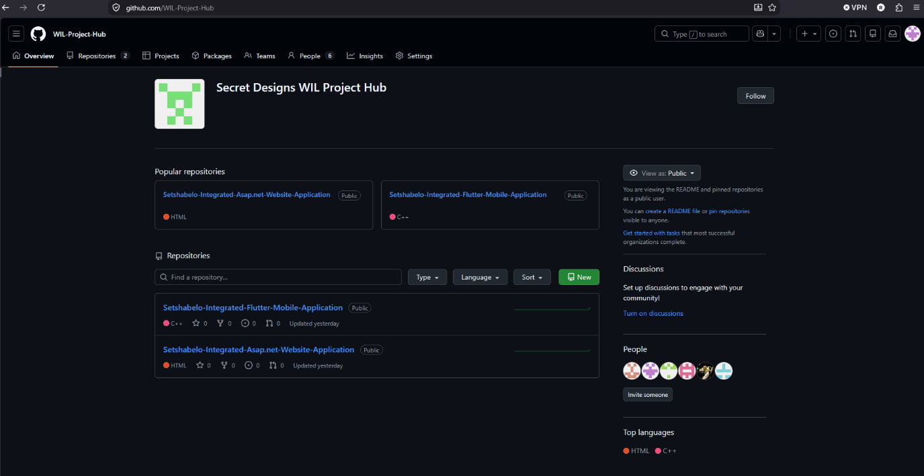
Github project repository: https://github.com/WIL-Project-Hub
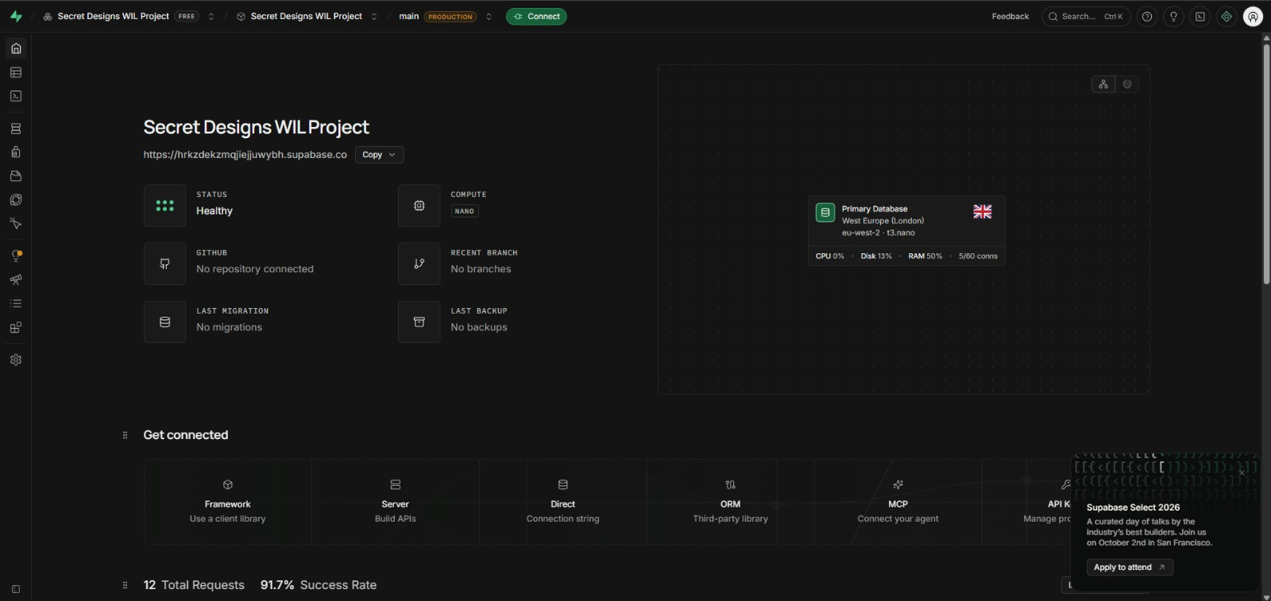
Supabase project: https://supabase.com/dashboard/project/hrkzdekzmqjiejjuwybh

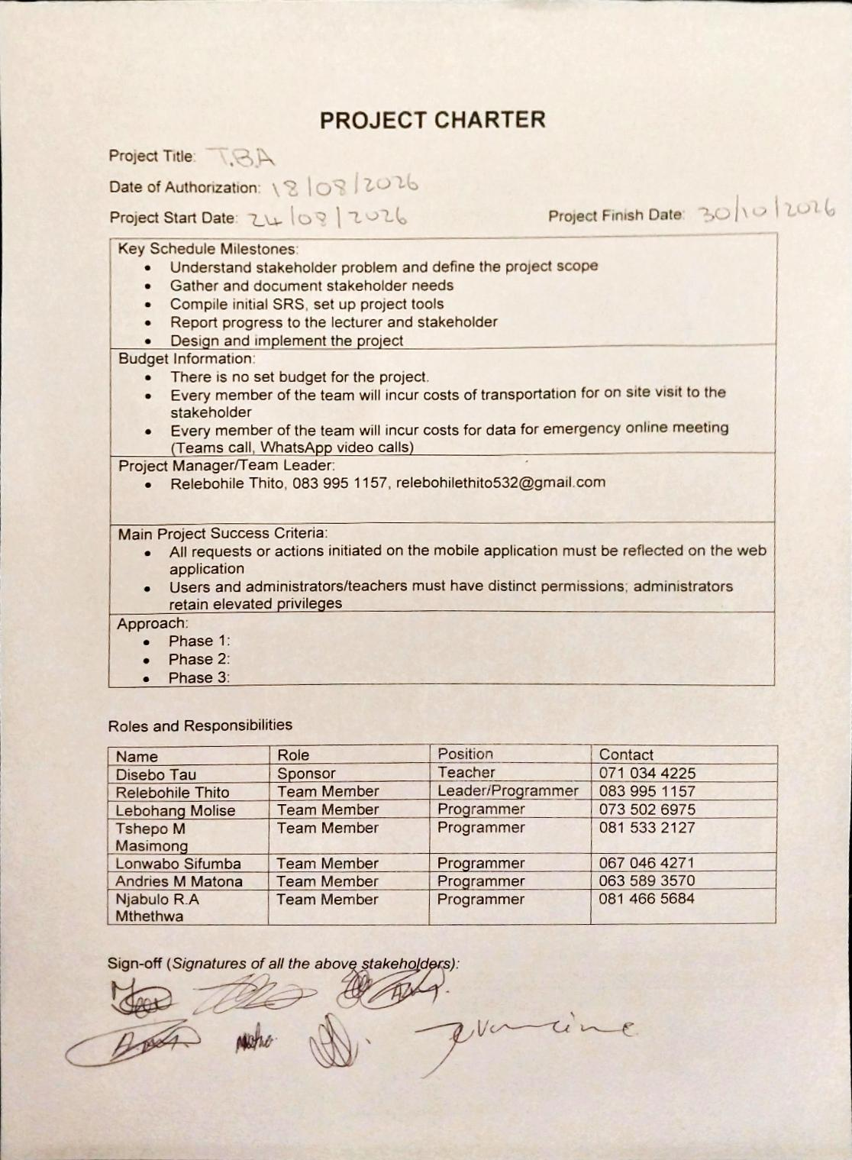
Project charter signed by everyone in attendance

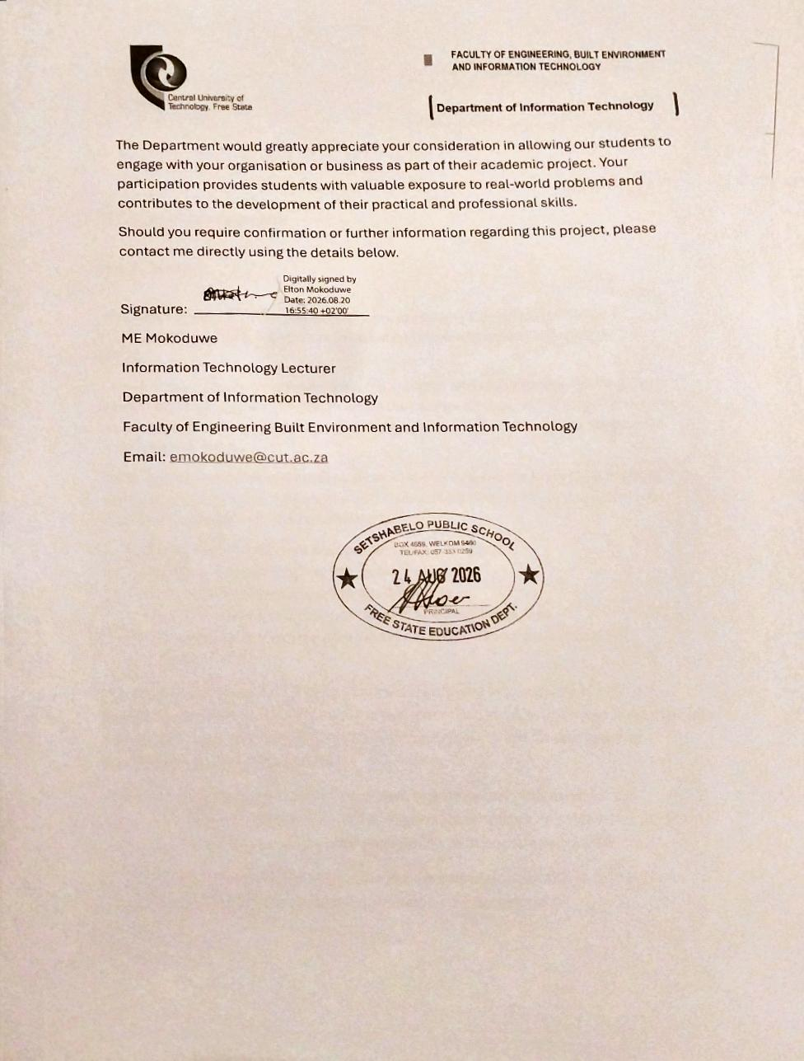
WIL letter stamped by sponsor organisation

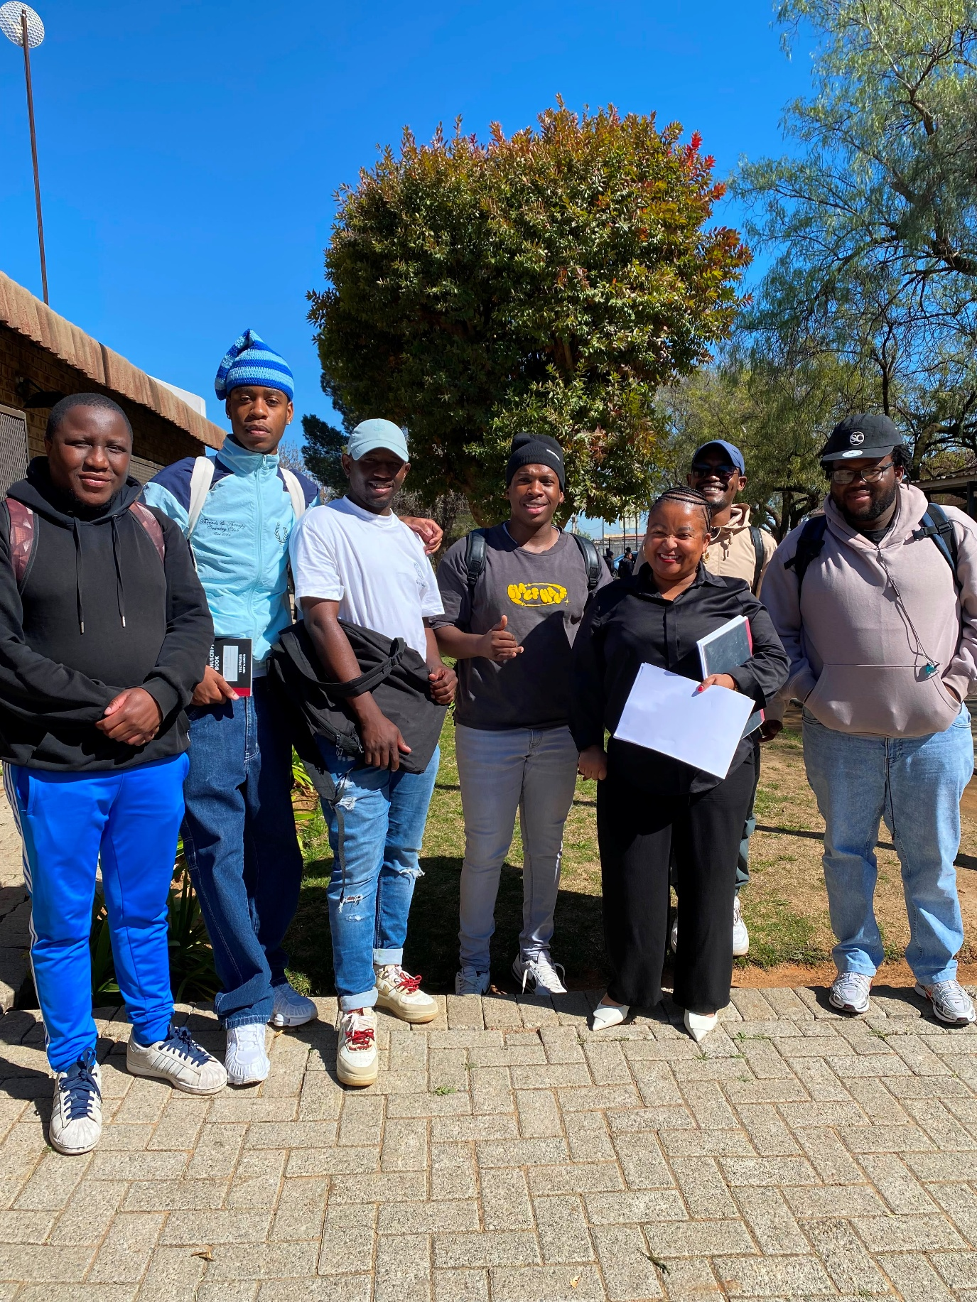
Picture of the team with the stakeholder(Disebo Tau) after a meeting

UNIT 3 – System Architecture & Design
System Architecture & Design

23. Main System Components
Component | Purpose
Flutter Mobile Application | Provides mobile functionality for the intended mobile users
ASP.NET Web Application | Provides web functionality for the intended web or administrative users
Supabase Authentication | Manages authentication where required
Supabase Database | Stores information used by both applications
Supabase Storage | Stores files or documents where required

24. System User and Roles
User / Role | Uses | Main purpose
Parent / Guardian | Flutter | Create an account, submit learner applications, upload documents, view application status, view school updates and achievements
School Admins | ASP.NET | Log in, view all applications, accept or reject applications, leave comments, publish school updates and achievements

25. Component Responsibilities
Component | Main Responsibilities
Flutter | Allow parents to register and log in, complete the multi-step application form, upload supporting documents, view application status, view school updates, and view achievements.
ASP.NET | Allow admins to log in, view all submitted applications, accept or reject applications, add comments, publish school updates, and publish achievements.
Supabase Authentication | Verify user identity and differentiate between Parent and Admin roles.
Supabase Database | Store user profiles, parent and admin records, applications, documents metadata, comments, school updates, and achievements.
Supabase Storage | Store uploaded files (birth certificates, parent IDs, etc) securely.

26. Main Data Flows
From | To | Information Exchanged
Parent | Flutter | Login credentials, application form data, document uploads
Flutter | Supabase Auth | Authentication requests (sign up, sign in)
Flutter | Supabase Database | Application data, status requests
Flutter | Supabase Storage | Uploaded documents
Supabase Database | Flutter | Application status, school updates, achievements
Supabase Storage | Flutter | Document URLs for viewing
Admin | ASP.NET | Login credentials, review decisions, published content
ASP.NET | Supabase Auth | Authentication requests (admin login)
ASP.NET | Supabase Database | Application retrieval, status updates, content publishing
Supabase Database | ASP.NET | All application data, comments, published content
Admin | ASP.NET | Accept/reject decisions, comments, new updates

27. System Architecture Diagram
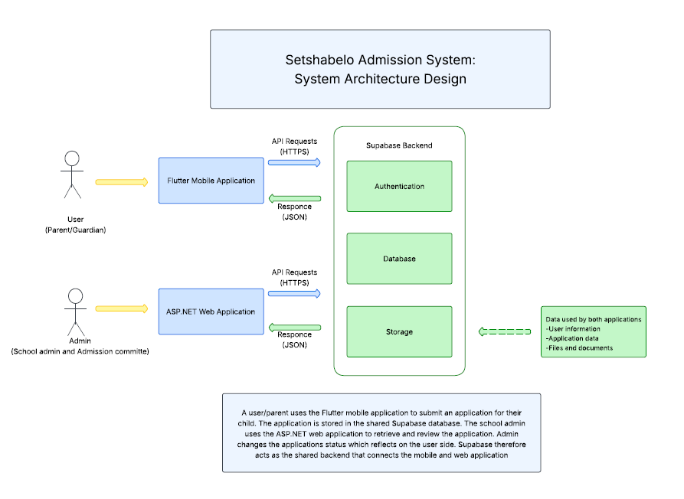
A user/parent uses the Flutter mobile application to submit an application for their child. The application is stored in the shared Supabase database. The school admin uses the ASP.NET web application to retrieve and review the application. Admin changes the applications status which reflects on the user side. Supabase therefore acts as the shared backend that connects the mobile and web application.

28. UML & Database Design
Use Case Diagram
Identifying Actors
Actor | What does this actor need to do?
Parent / Guardian | Register an account, log in, submit learner applications, upload supporting documents, view application status, view school updates, view school achievements
School Admin | Log in, view all submitted applications, review applications, accept or reject applications, leave comments for parents, publish school updates, publish school achievements

29. Identifying Use Cases
Actor | Possible Use Case
Parent / Guardian | Register
Parent / Guardian | Login
Parent / Guardian | Submit Application
Parent / Guardian | Upload Documents
Parent / Guardian | View Application Status
Parent / Guardian | View Application Comments
Parent / Guardian | View School Updates
Parent / Guardian | View Achievements
School Admin | Login
School Admin | View All Applications
School Admin | Review Application
School Admin | Accept Application
School Admin | Reject Application
School Admin | Add Comment
School Admin | Publish School Update
School Admin | Publish Achievement

30. Use Case Diagram
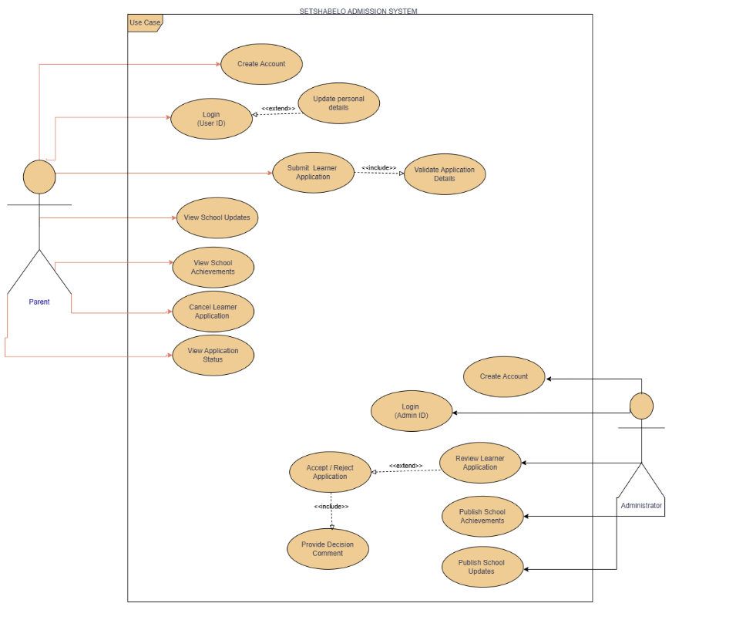

31. Sequence Diagrams
Sequence Diagram 1: Parent Submits Application
Participant | Role
Parent | Starts the process
Flutter App | Receives the parent's request
Supabase Auth | Verifies the parent's identity
Supabase Database | Stores the application
Supabase Storage | Stores the uploaded documents

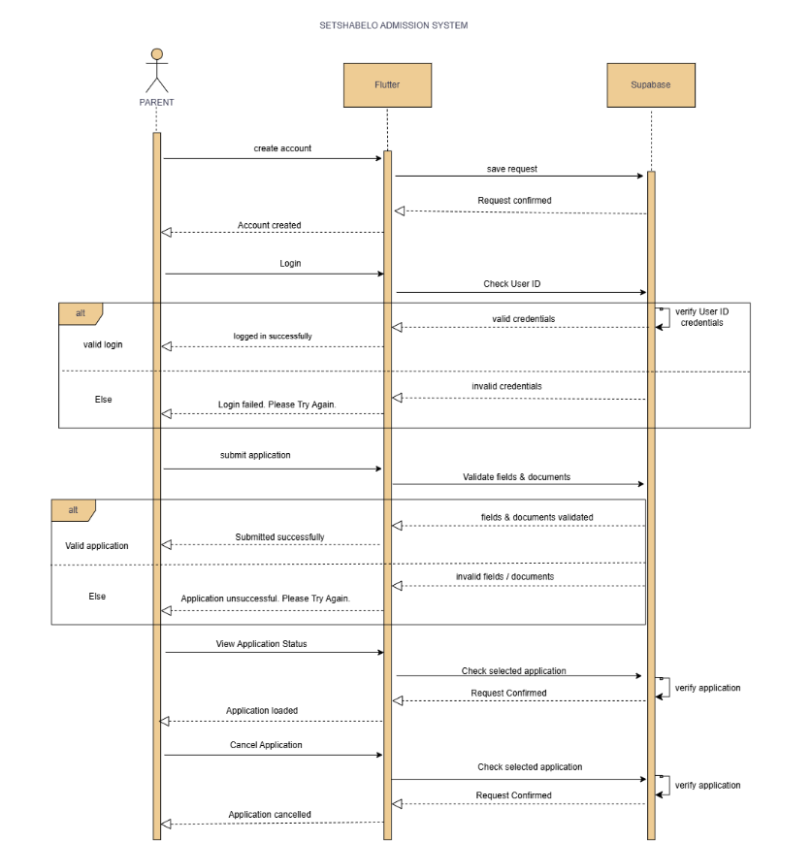

Sequence Diagram 2: Admin Reviews Application
Participant | Role
Admin | Starts the management action
ASP.NET Web App | Processes the admin's action
Supabase Auth | Verifies the admin's identity
Supabase Database | Updates the shared data

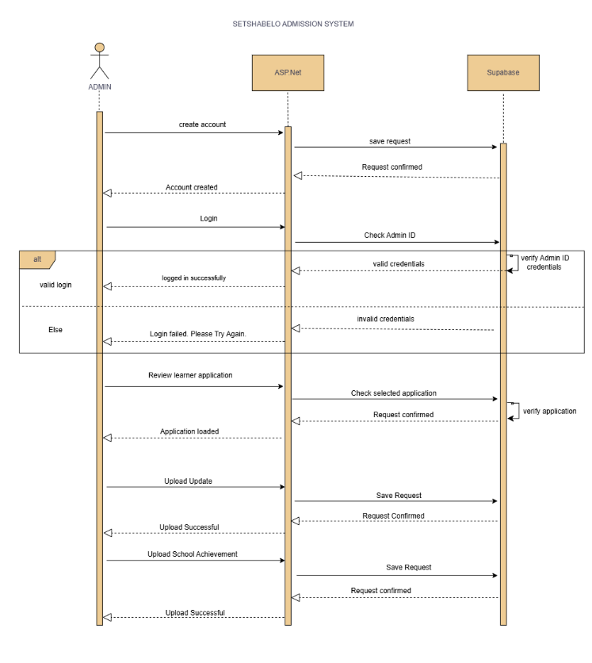

32. Entity Relationship Diagram
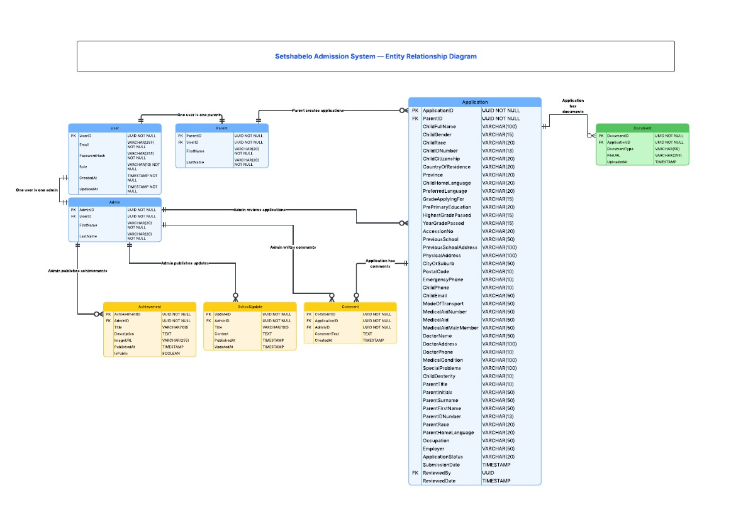

User Interface Design

33. Required Flutter Screens
Flutter Screen | User | Purpose | Related Requirement
Splash / Login | Parent | Authenticate user | FR1, FR7
Register | Parent | Create a new parent account | FR1
Parent Home | Parent | Main dashboard after login | FR1, FR2
Child Info (Step 1 of form) | Parent | Capture child's personal details | FR2
Address (Step 2 of form) | Parent | Capture home address and contact details | FR2
Medical Info (Step 3 of form) | Parent | Capture medical aid and doctor details | FR2
Parent Info (Step 4 of form) | Parent | Capture parent details | FR2
Documents (Step 5 of form) | Parent | Upload supporting documents | FR2, IR2
Review & Submit (Step 6 of form) | Parent | Review all info and submit | FR2
My Applications | Parent | View all submitted applications and their status | FR3
Application Detail | Parent | View full detail of a single application + comments | FR3
School Updates | Parent | View announcements from the school | FR5
Achievements | Parent | View school achievements | FR6

34. Required ASP.NET Screens
ASP.NET Page | User | Purpose | Related Requirement
Login | Admin | Authenticate admin | FR7, IR4
Admin Dashboard | Admin | Overview of applications and quick actions | FR4
Application List | Admin | View all submitted applications | FR4
Application Detail | Admin | Accept, reject, or comment on an application | FR4
Publish Update | Admin | Create and publish a school update | FR8
Publish Achievement | Admin | Create and publish an achievement | FR8
Manage Content | Admin | Edit or delete existing updates and achievements | FR8

Navigation Between Screens

35. Flutter Mobile Navigation Flow
Starting Screen | User Action | Next Screen
Splash / Login | Tap "Register" | Register
Register | Tap "Login" | Splash / Login
Splash / Login | Successful login (Parent) | Parent Home
Parent Home | Tap "New Application" | Child Info (Step 1)
Child Info | Tap "Save" | Address (Step 2)
Address | Tap "Save" | Medical Info (Step 3)
Medical Info | Tap "Save" | Parent Info (Step 4)
Parent Info | Tap "Save" | Documents (Step 5)
Documents | Tap "Save" | Review & Submit (Step 6)
Review & Submit (Step 6) | Tap "Apply" | Success Screen
Success Screen | Tap “Back to dashboard” | Parent Home
Parent Home | Tap "My Applications" | My Applications
My Applications | Tap an application | Application Detail
Parent Home | Tap "Achievements" | Achievements
Any screen | Tap "Logout" | Splash / Login

36. ASP.NET Web Navigation Flow
Starting Screen | User Action | Next Screen
Login | Tap "Sign In" | Admin Dashboard
Admin Dashboard | Tap "View All Applications" | Application List
Application List | Tap an application | Application Detail
Application Detail | Tap "Accept" or "Reject" | Application Detail (updated status)
Application Detail | Tap "Back" | Application List
Admin Dashboard | Tap "Publish Update" | Publish Update
Publish Update | Tap "Publish" | Admin Dashboard (with success)
Admin Dashboard | Tap "Publish Achievement" | Publish Achievement
Publish Achievement | Tap "Publish" | Admin Dashboard (with success)
Any page | Tap "Logout" | Login

37. Mobile & Web Integration
Flutter Action | Supabase Data | ASP.NET Action
Parent submits application | Application row created | Admin views application in list
Parent uploads documents | Document rows created and files in Storage | Admin views documents from Application Detail
Parent views status | Fetches application_status from Application | Admin updates status to "Accepted" or "Rejected"
Parent views updates | Fetches SchoolUpdate rows | Admin publishes new SchoolUpdate
Parent views achievements | Fetches Achievement rows | Admin publishes new Achievement

38. Stakeholder Feedback
Item | Detail
Date of feedback | 16 September 2026
Designs shown | All Flutter Wireframes
Stakeholder comments | The form is easy to follow, and it includes the important fields. The design is appropriate and fits with the school. The screens look good
Changes requested | None
Changes made | None
Evidence available | Signed Feedback Sheet

39. Updated System Design
Design Artifact | Change Made | Reason
Architecture | No change | Architecture confirmed
Use Case Diagram | No change | Use cases confirmed
Sequence Diagram | No change | Processes confirmed
ERD | No change | ERD already supports optional fields
Flutter Interface | Removed emblem as background | Stakeholder feedback
ASP.NET Interface | No change | Interfaces confirmed

40. Unit 3 Evidence
Flutter Mobile Wireframes: https://www.figma.com/proto/DtQKcA5cbFv7hiG46obRGQ/Setshabelo-Admission-System?node-id=2-3&p=f&t=Gs5yKR4SaZWXt9bd-0&scaling=scale-down&content-scaling=fixed&page-id=0%3A1&starting-point-node-id=2%3A3
ASP.NET Web User Frames: https://www.figma.com/proto/DtQKcA5cbFv7hiG46obRGQ/Setshabelo-Admission-System?node-id=307-1244&p=f&t=u551uaPYP606NPV4-0&scaling=scale-down&content-scaling=fixed&page-id=22%3A319&starting-point-node-id=307%3A1244
ASP.NET Web Admin Frames: https://www.figma.com/proto/DtQKcA5cbFv7hiG46obRGQ/Setshabelo-Admission-System?node-id=101-1243&p=f&t=P6thFviGmJ0minRB-0&scaling=min-zoom&content-scaling=fixed&page-id=101%3A1242&starting-point-node-id=101%3A1243
Updated GitHub Documentation Link: https://github.com/WIL-Project-Hub
Supabase schema: https://supabase.com/dashboard/project/hrkzdekzmqjiejjuwybh/database/schemas
ERD Diagram: https://lucid.app/lucidchart/092e1500-ca6c-49c8-b6a4-ada472e20ee6/edit?page=0_0&invitationId=inv_57f5bd22-f6ba-4854-a039-97a8b9d8d776#
System Design: https://lucid.app/lucidchart/daf0e515-197b-4114-a3f5-ab62878445c1/edit?invitationId=inv_4695dfe3-c4ba-48db-945b-b2529c33d526

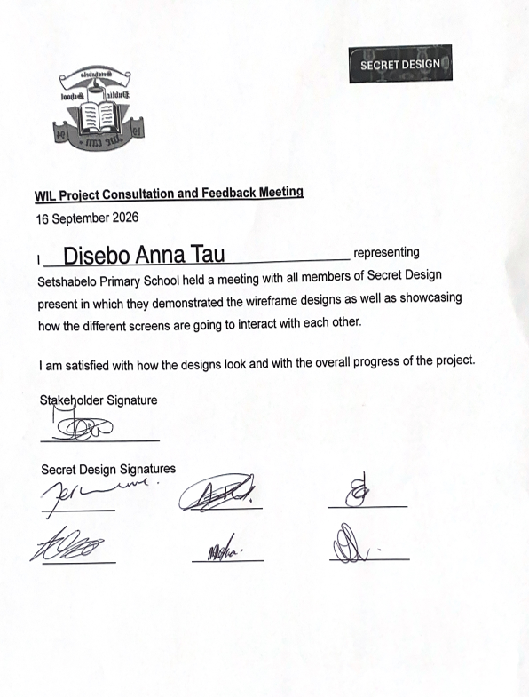
Signed design confirmation letter
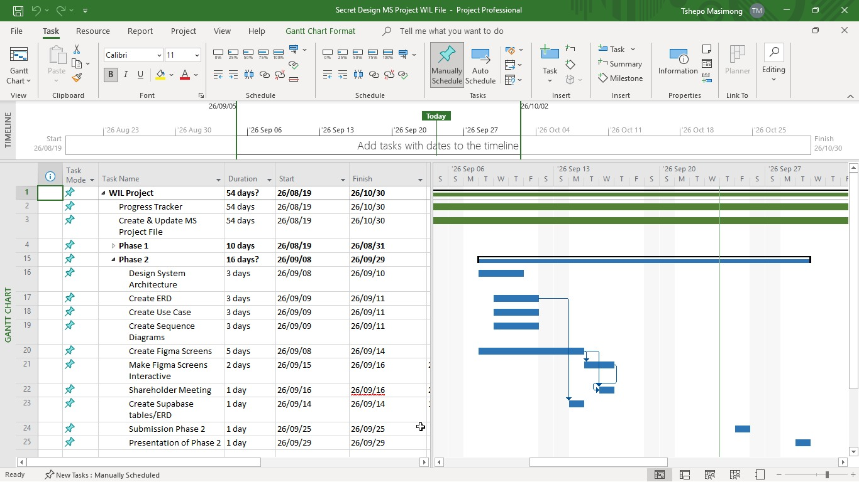
MS Project Schedule

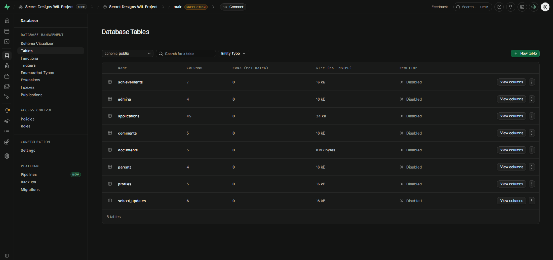
Supabase Tables: https://supabase.com/dashboard/project/hrkzdekzmqjiejjuwybh/database/tables

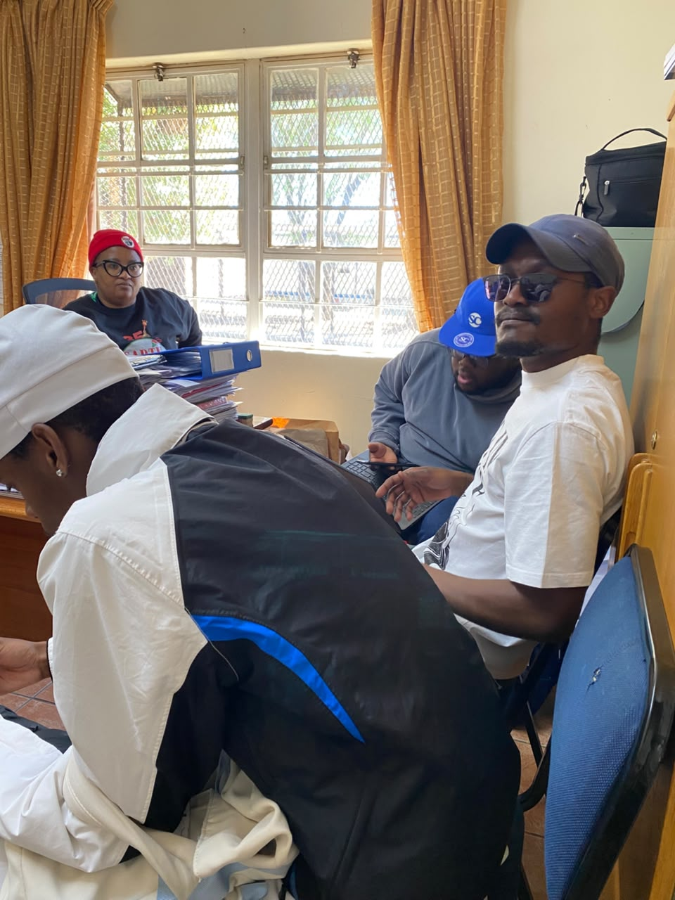
Meeting with the stakeholder
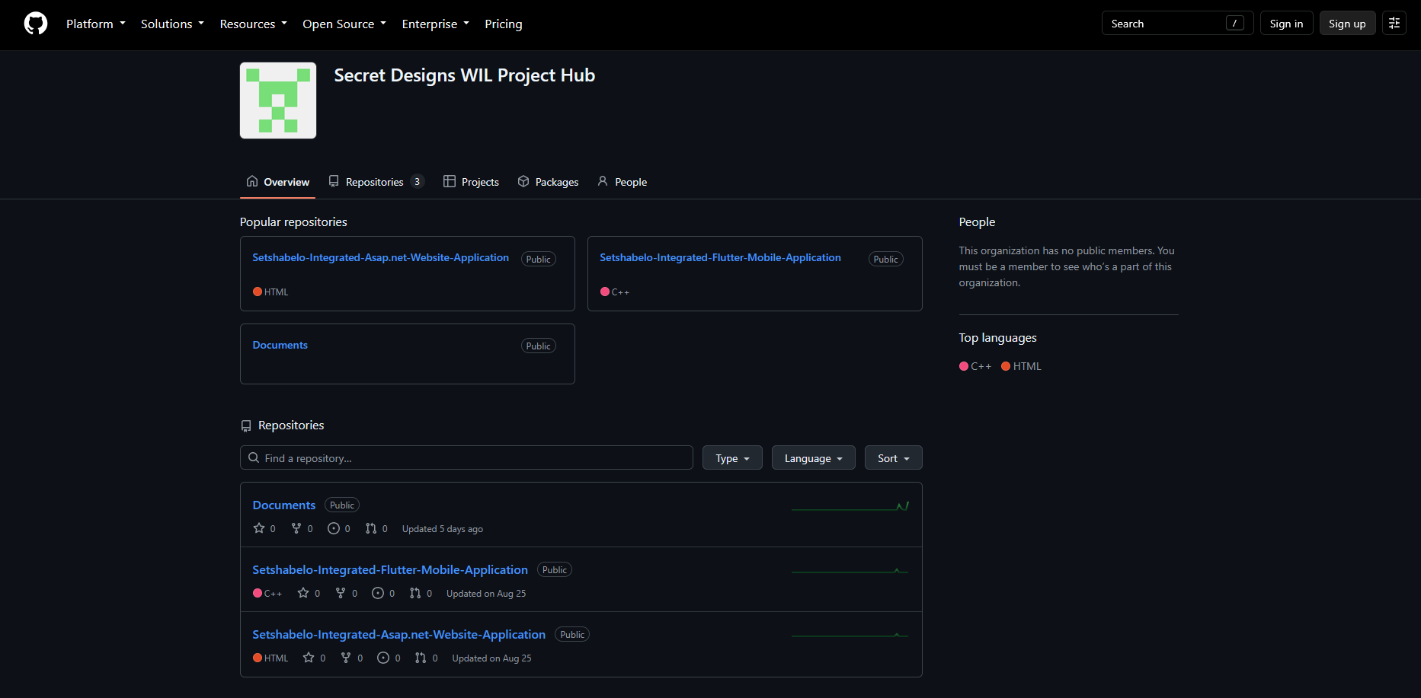
Github repository

Unit 4: System Development and Implementation
System Development and Implementation

41.Approved Database Design Review
Entity / Table | Purpose | Main fields
applications | Store application information | application_id, parent_id, admin_id, parent_first_name, parent_last_name, child_full_name, grade_applying_for,
parents | Store the parent information | Parent_id, user_id,first_name, last_name
documents | Stores documents required for the application | document_id, application_id, document_type, file_url, uploaded_at
school_updates | Stores school news and update information | update_id, admin_id, title, content, published_at, updated_at
achievements | Stores the schools’ achievements information | achievement_id, admin_id, title, description, image_url, published_at, is_public
comments | Stores the comments made by an admin on a parent’s application | comment_id, application_id, admin_id, comment_text, created_at
admins | Stores the admins information | admin_id, user_id, first_name, last_name
profiles | Stores information for all the users of the application | id, role, email, created_at, updated_at

42. Backend for both applications
Application | Backend Interaction
Flutter | Submit application, review application status, view the school’s news and updates, view the schools’ achievements and awards
ASP.NET | Submit application, review application status, view the school’s news and updates, view the schools’ achievements and awards
ASP.NET (admin) | Retrieve and review all applications submitted, update application status, manage school updates and achievements

43. Approved Mobile Application Requirements
Mobile function | Related use case or requirement | Required screen
Sign in | Login | Login screen
Create application | Apply | Apply form screen
Upload documents | Apply | Apply form last step screen
View application status | View Status | Application details screen
View school updates | View Updates | School Updates screen
View school achievements | View Achievements | School Achievements screen

44. Mobile Application Flow
Module | Screen / View | Purpose | User Action | Next step
Authentication | Login | Allow existing users to sign in | Enter required login fields then tap Lognin button | Successful login redirects to the user’s dashboard
 | Register | Create parents account | Enter required sign in fields then tap Sign in button | Successful sign in redirects to the user’s dashboard
Dashboard | Home | Home screen for parents with recent activities | Taps main navigation cards on the dashboard | Redirects to the screen of the navigation card tapped on
Applying | ApplicationWizardScreen | Application form with multiple steps | Fill required information and tap next on each step | Successful application submission redirects to dashboard
View Status | My Applications | Track multiple applications submitted and view each ones status | Tap the application you want to track | Redirect to the navigation tapped
Updates | SchoolUpdates | View school updates from the admin | Scroll through notifications and pull-to-refresh | Redirect to the navigation tapped
Achievements | SchoolAwars | View school awards and achievements posted by the admin | Scroll through achievements and pull-to-refresh | Redirect to the navigation tapped

45. Developed Mobile Screens

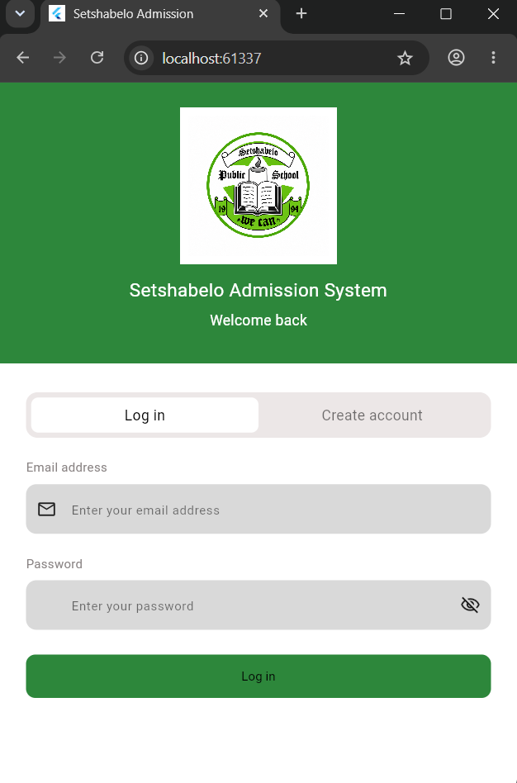

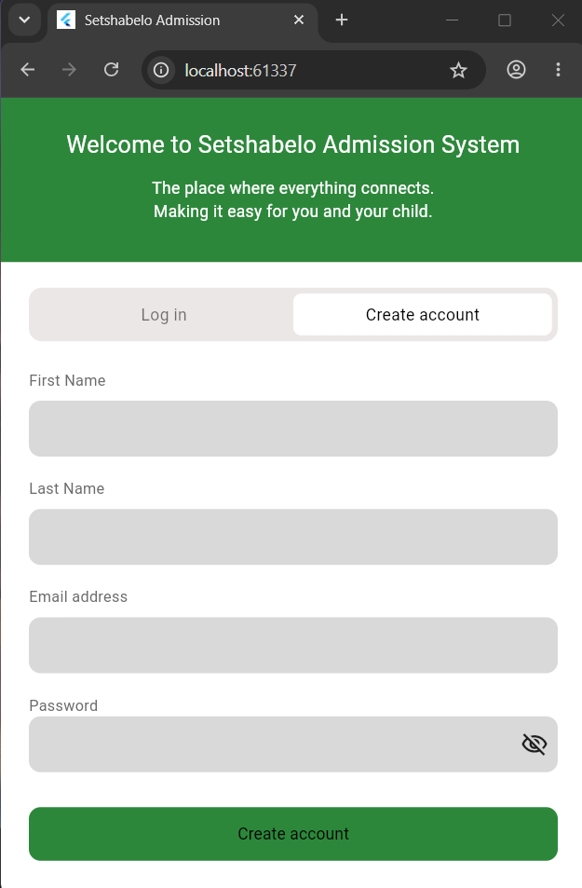

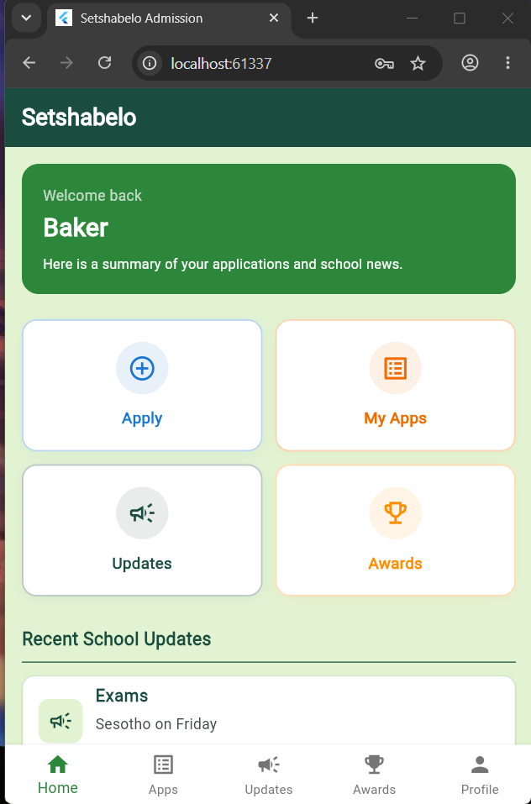

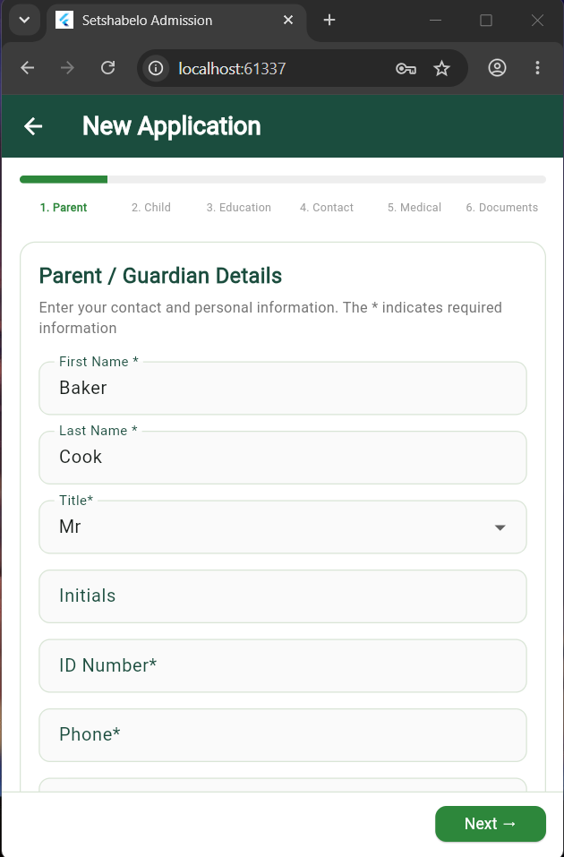

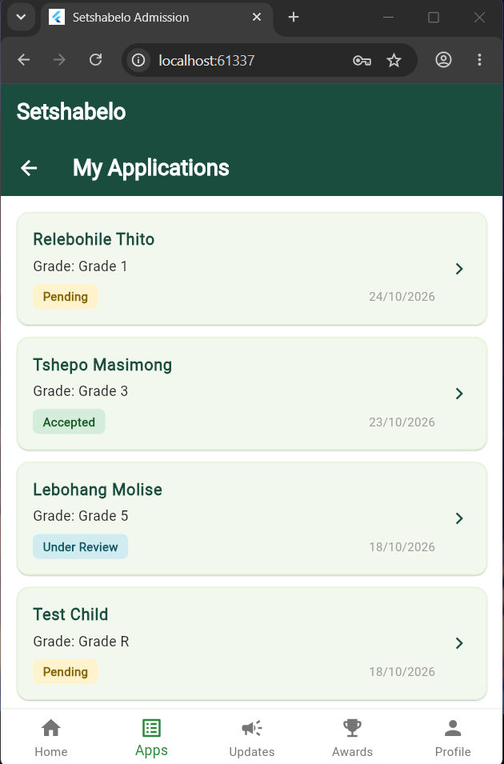

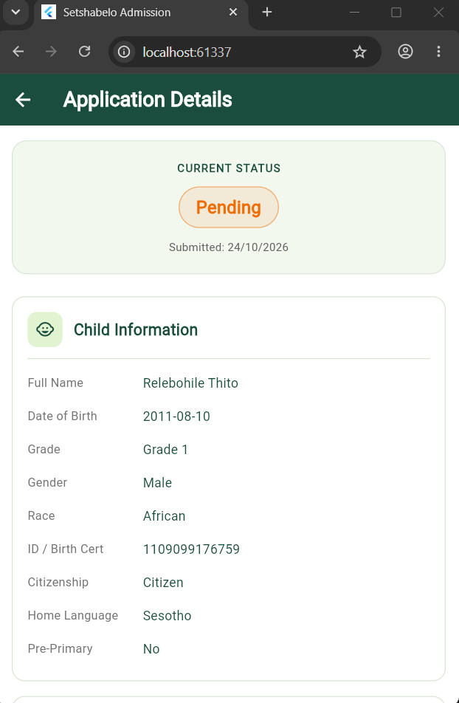

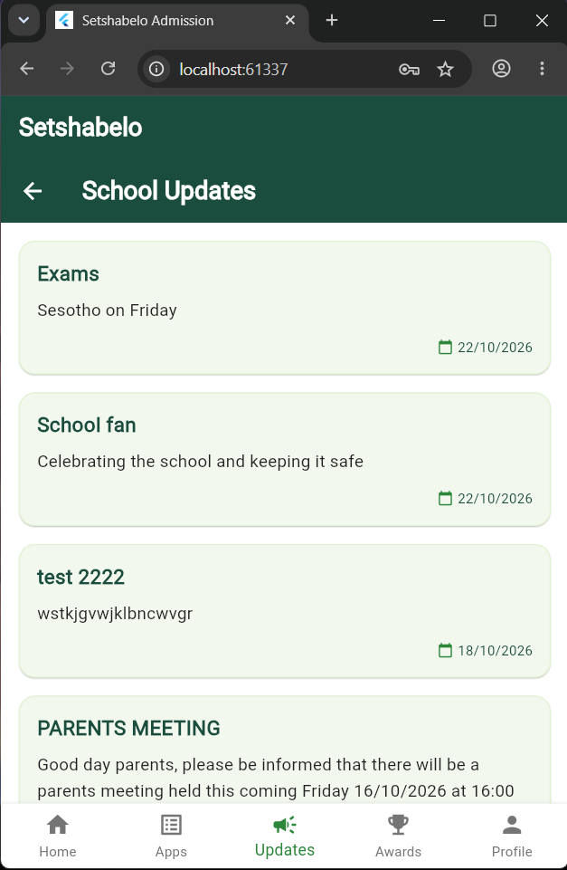

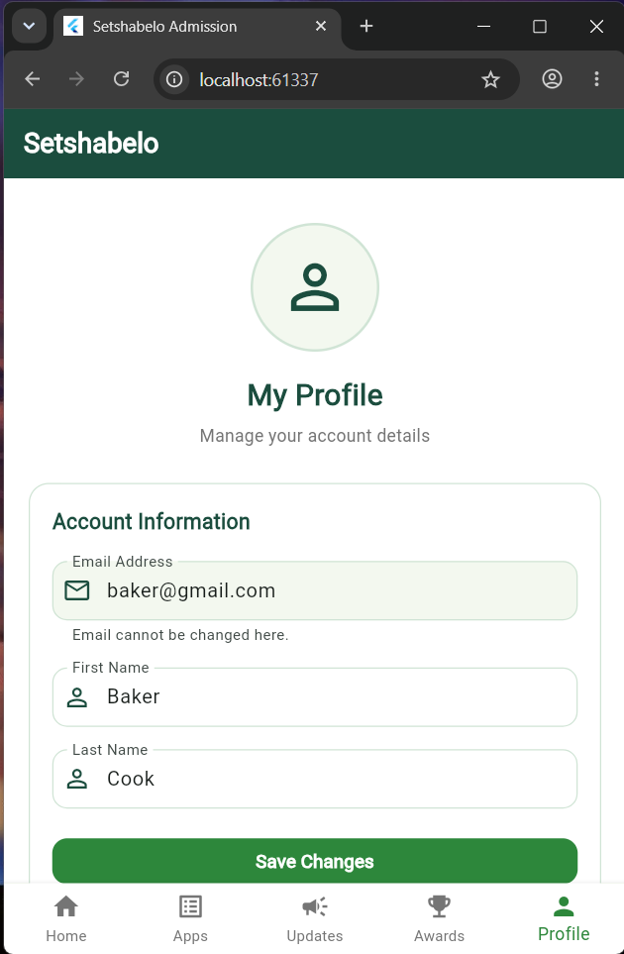

46. Web Application Requirements
Mobile function | Related use case or requirement | Required screen
Sign in | Login | Login screen
View all applications |  | Dashboard screen
Update application status |  | Application details screen
Publish updates |  | Publish School Update screen
Publish achievements |  | Publish Achievement screen

47. Web Application Flow
Module | Screen / View | Purpose | User Action | Next step
Authentication | Login | Allow existing admins to sign in | Enter required login fields then tap Login button | Successful login redirects to the admins dashboard
Dashboard | Home | Home screen for admins with activities to perform | Taps main navigation on the dashboard | Redirects to the screen of the navigation tapped on
Reviewing applications | Applications | View multiple submitted applications and can filter search | Filter according to applications they want to see and tap on the application to view it | Redirects to the application details screen of that application
Manage Content | Manage Content | View all the recently published school updates and achievements | Tap view or edit or delete to view or edit or delete the content | Dialog box to delete if delete selected. Redirects to the content if view selected or to the edit screen if edit selected
Updates | Publish Update | Allows the admin to publish school updates to be seen by parents | Fill the title and description fields and publish the update | Redirect to the navigation tapped
Achievements | Publish Achievement | Allows the admin to publish school achievements to be seen by parents | Fill the title and description fields and attach the picture | Redirect to the navigation tapped

48. Developed Web Screens (Admin)
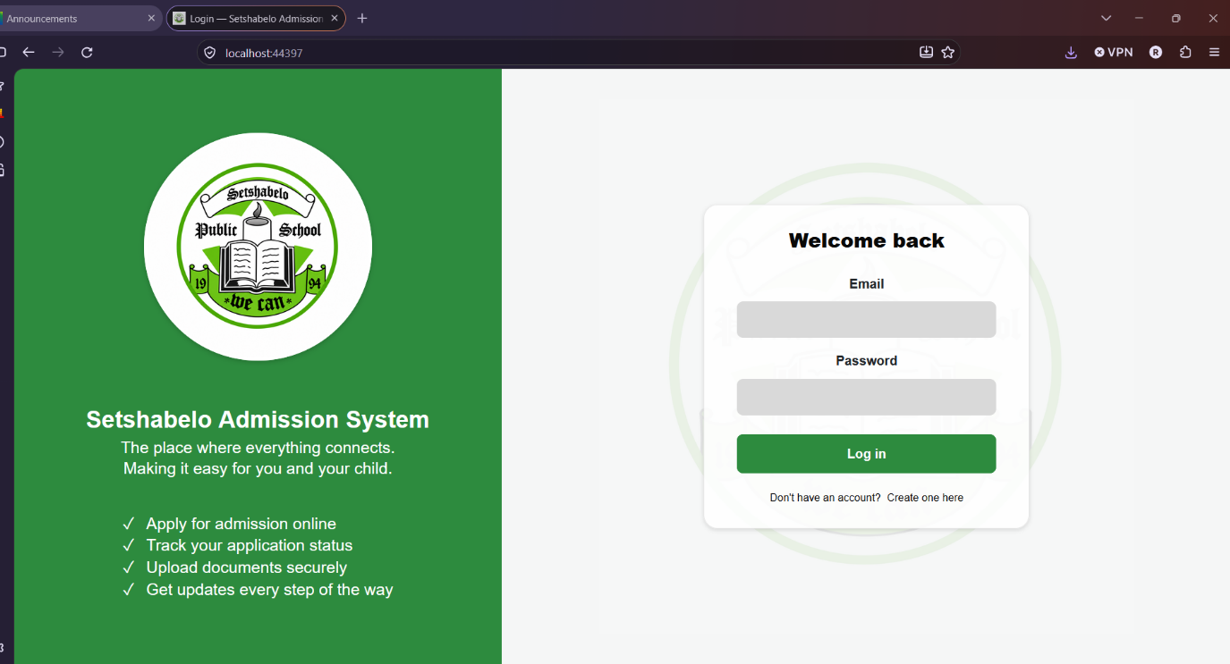

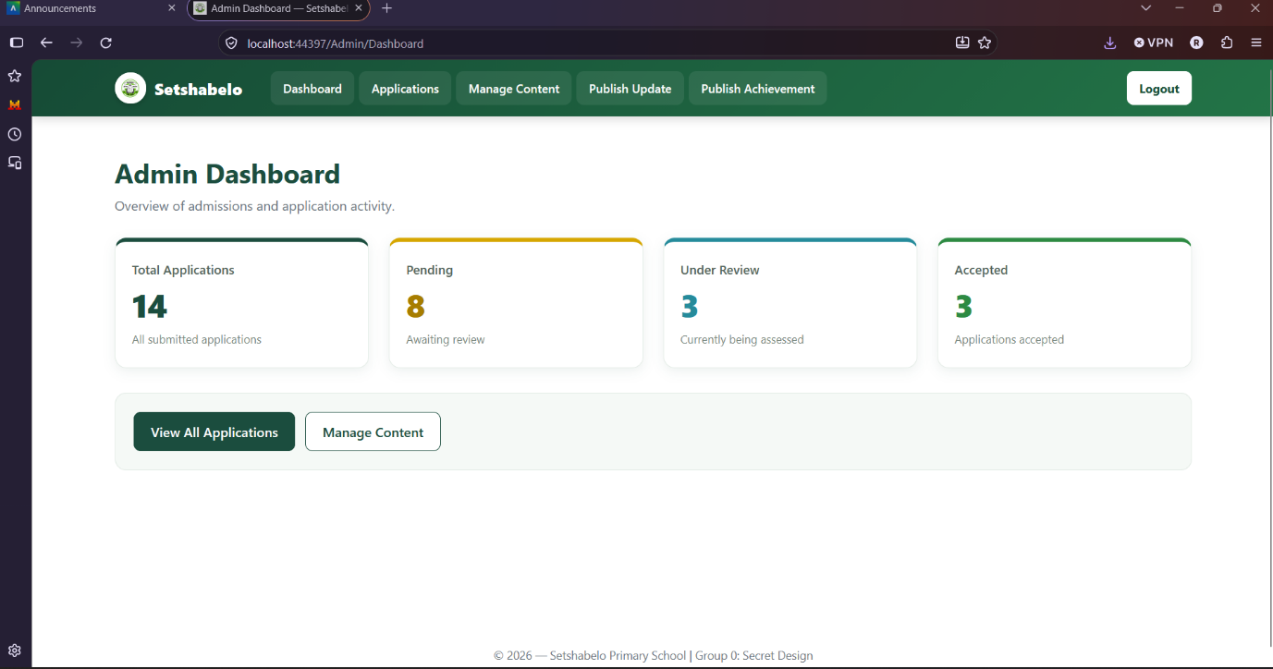

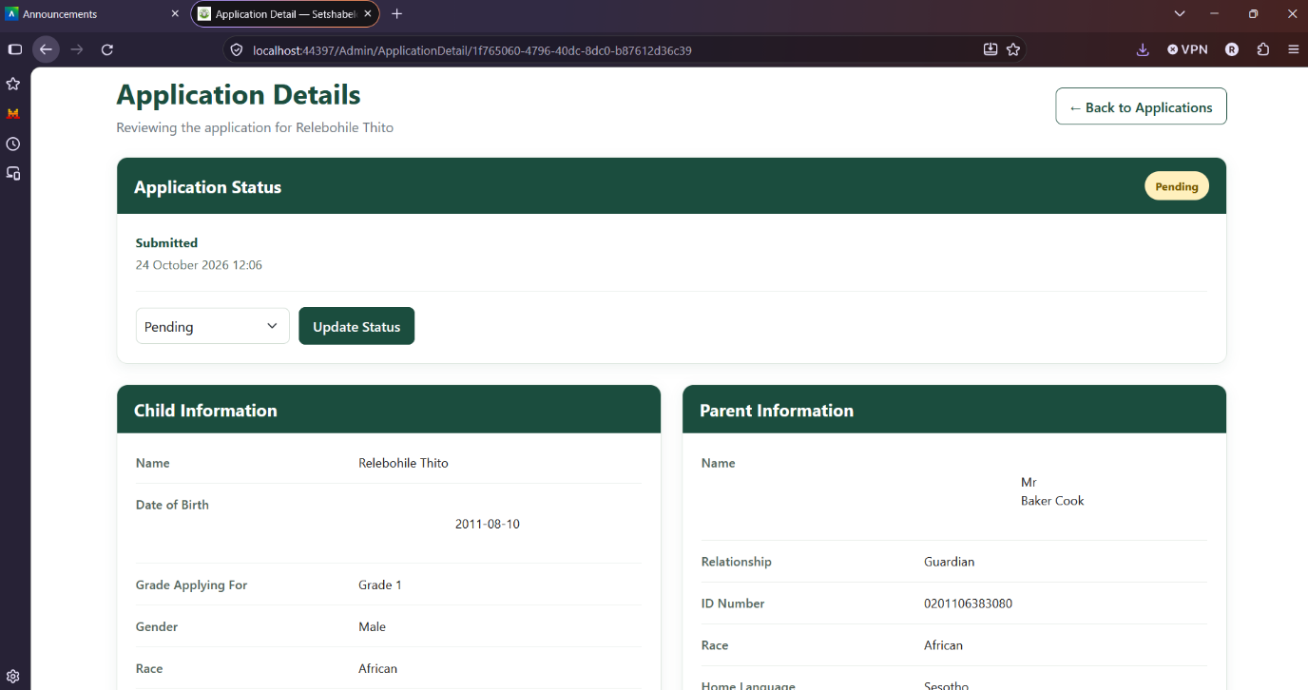

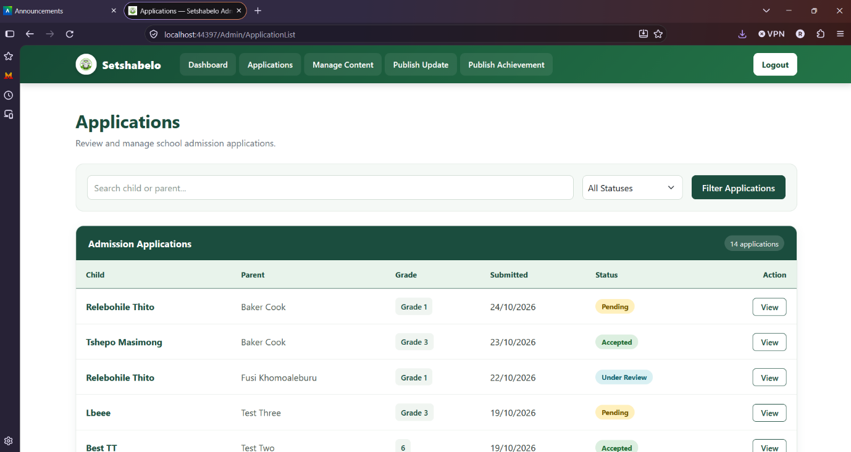

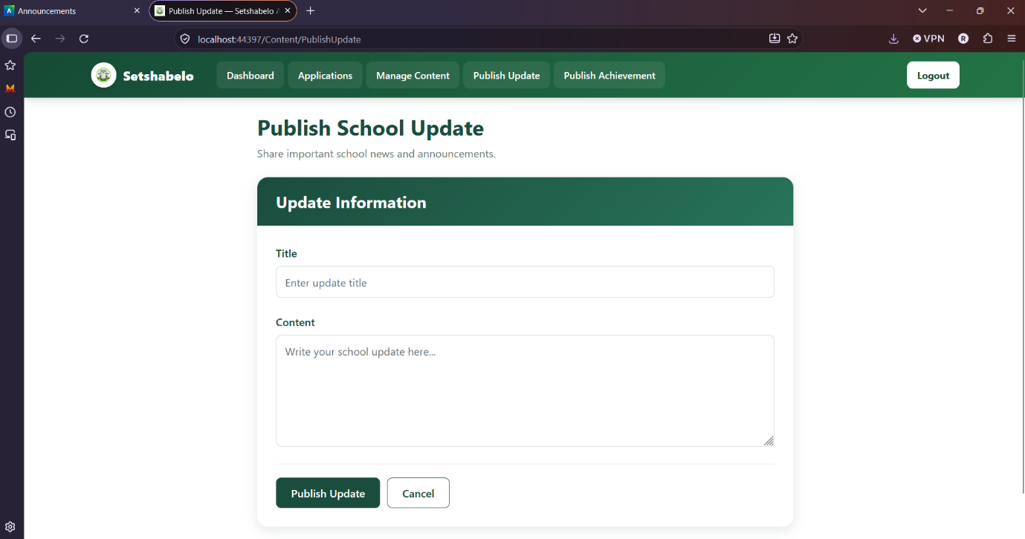

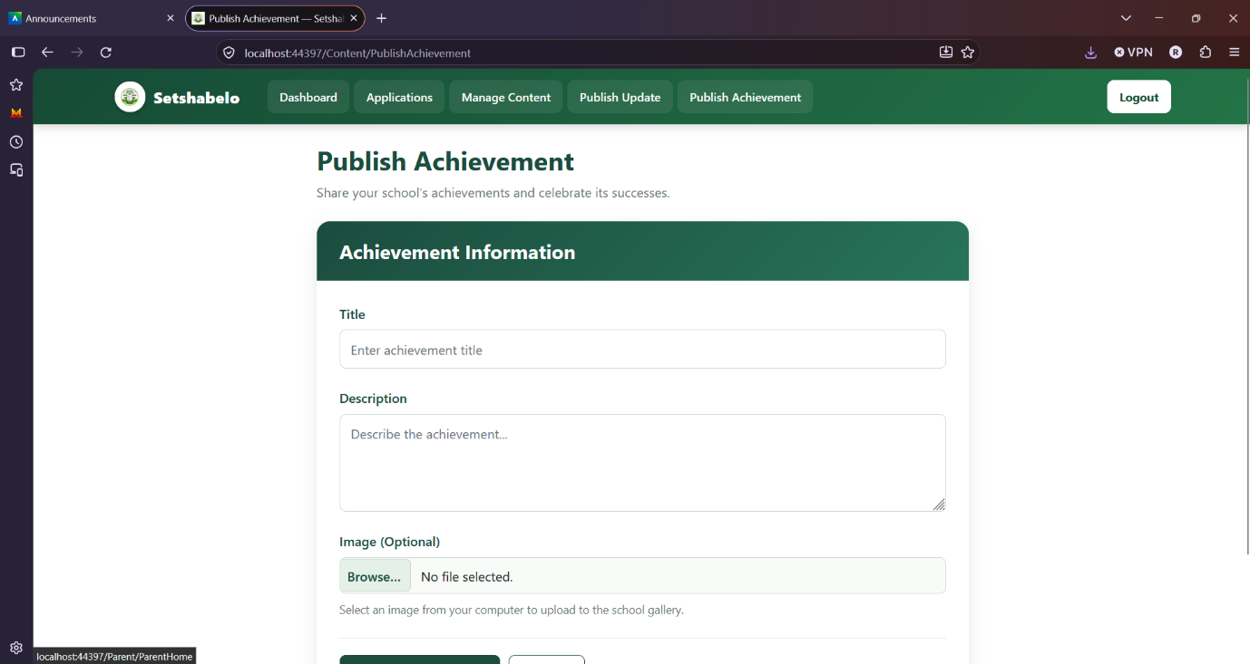

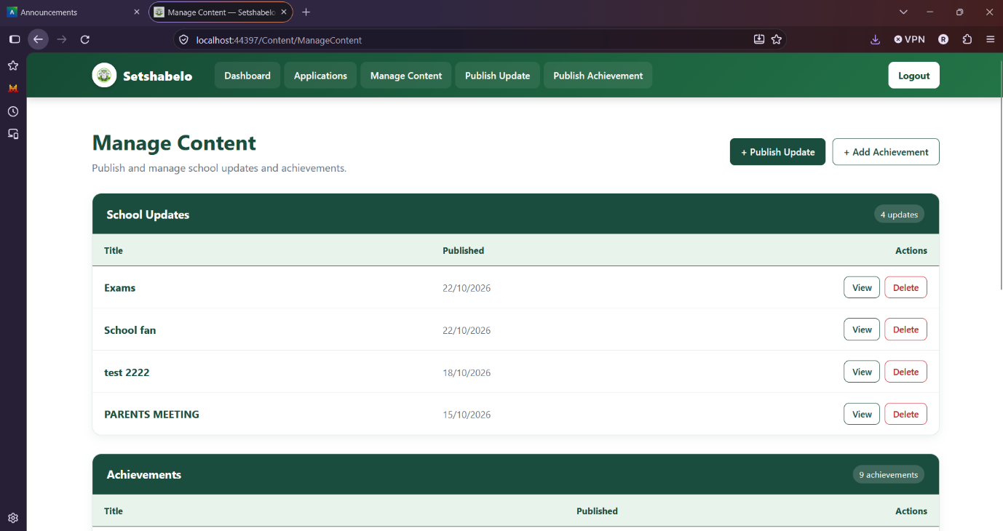

49. Approved Integration Design
Shared process | Action in Flutter | Action in ASP.NET | Shared information
Application submission | Parent submits an application | Admin views the application | Application details
Application acceptance | Parent views application status | Admin changes status to approve application | Application status
Application rejection | Parent views application status | Admin changes status to reject the application | Application status
School updates | Parent views the school’s updates | Admin publishes updates | Updates information
School achievements | Parent views the school achievements | Admin publishes events and achievements | Achievements information

50. Complete Integrated Application
- Parent creates an account
- Supabase stores the authentication details
- Parent applies
- Flutter saves the application in Supabase
- An admin logs in on the ASP.NET web application
- The web application retrieves the same application submitted by the parent from Supabase
- The admin changes the applications status and leaves a comment if needed
- ASP.NET updates the application status in Supabase
- The customer refreshes or reopens the applications Flutter screen to view application status and the updated status is reflected

51. Unit 4 Evidence
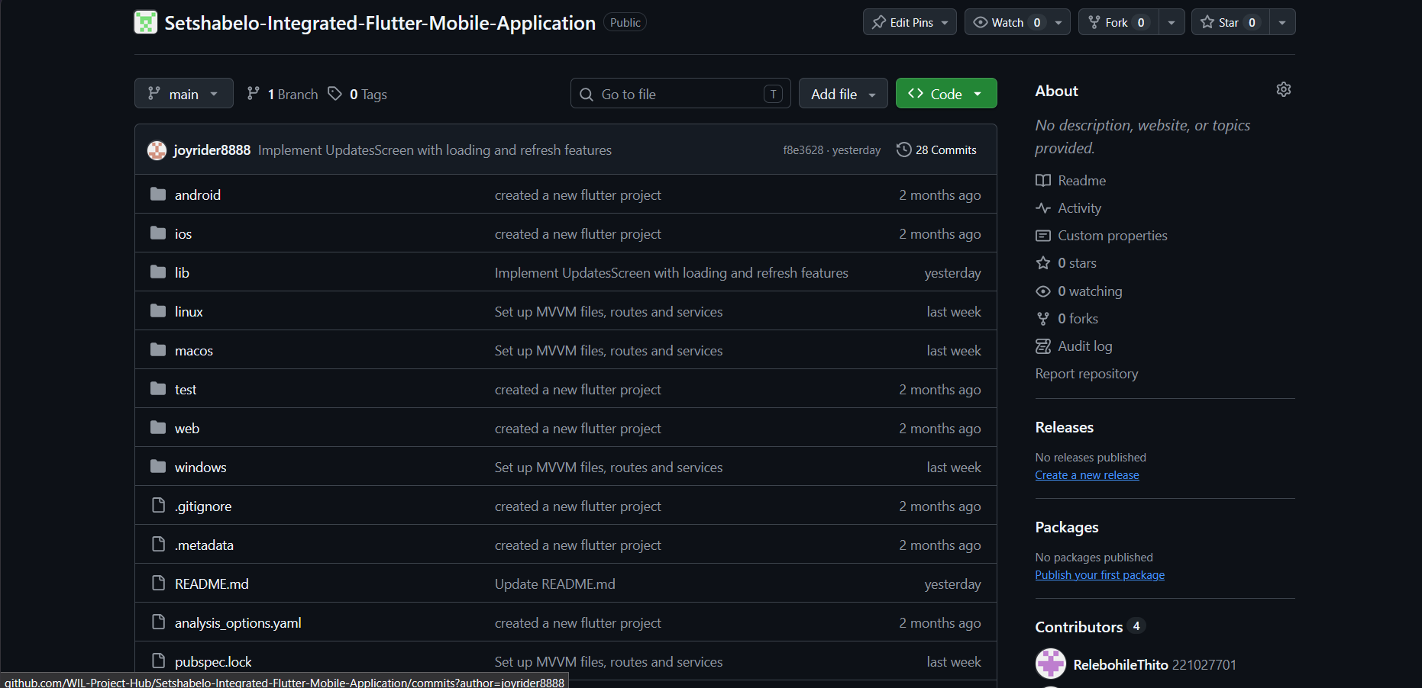
Flutter mobile application github repository: https://github.com/WIL-Project-Hub/Setshabelo-Integrated-Flutter-Mobile-Application

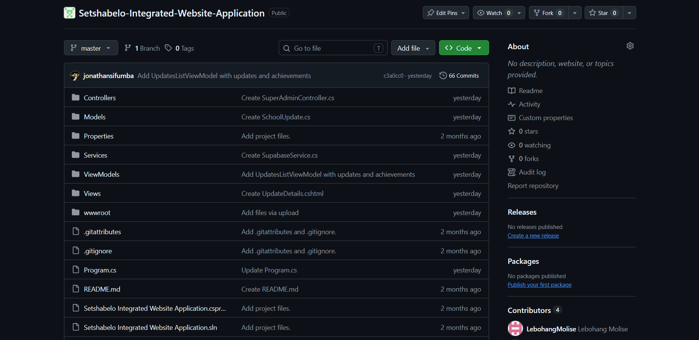
ASP.NET web application github repository: https://github.com/WIL-Project-Hub/Setshabelo-Integrated-Website-Application

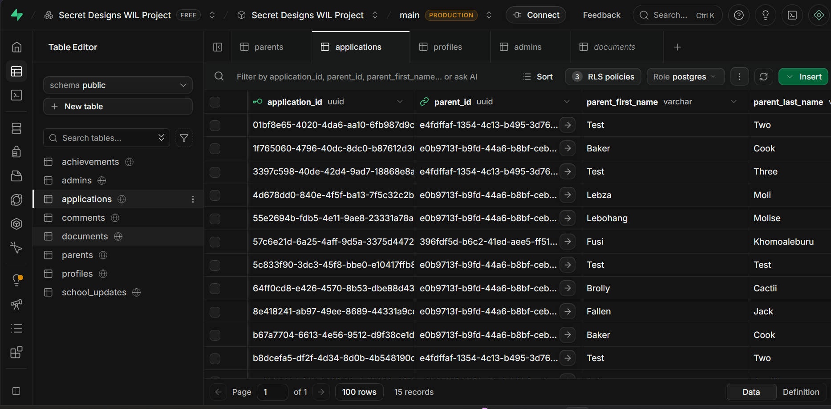
Supabase table

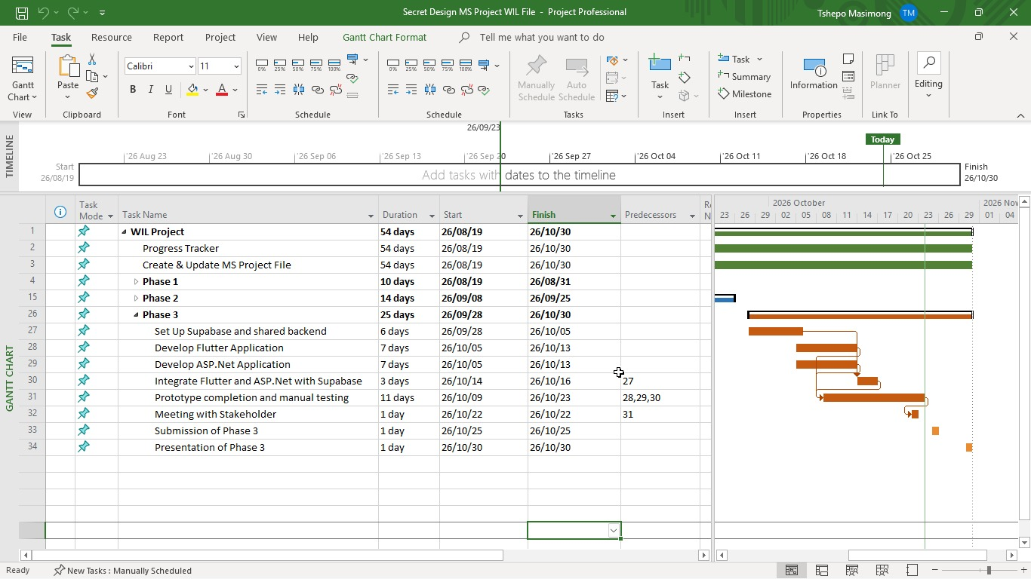
MS Project Schedule
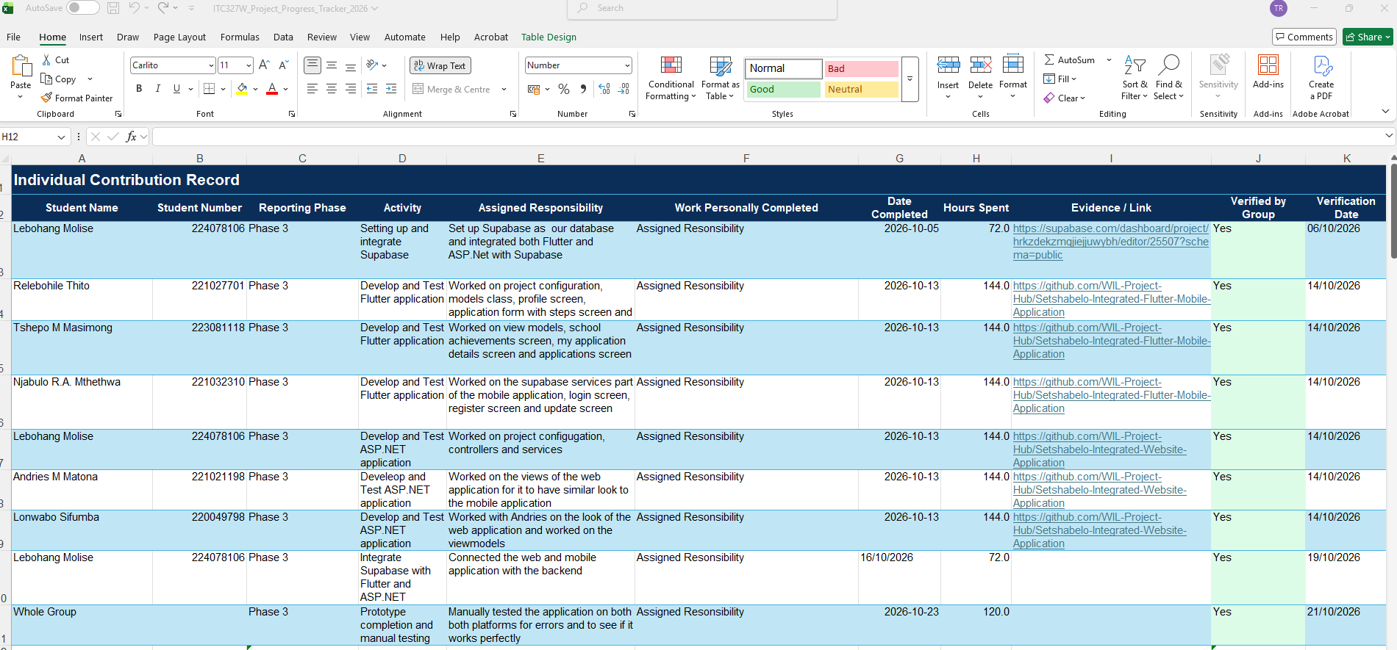
Progress Tracker
